Senior Project Object Model

Matrix Movie Manager

Matrix

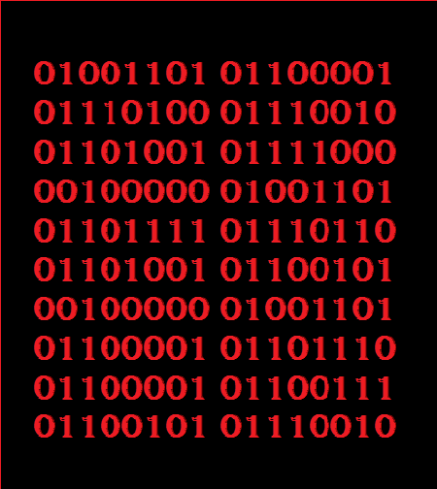

Release: 0.5

Version: 1.0

Date: 11/9/2016

Submitted By: Ryan Williams

Email: [ryan.williams@oit.edu](mailto:ryan.williams@oit.edu)

# Signatory Page

This document is accepted by:

Signature (Calvin Caldwell) Date

This document is submitted by:

Signature (Ryan Williams) Date

# Revision History

|  |  |  |  |  |  |
| --- | --- | --- | --- | --- | --- |
| Author | Company | Version | Date | Filename | Comments |
| Ryan Williams | Matrix | 1.0 | 11/9/2016 | Senior Project Object model | Created the document |
|  |  |  |  |  |  |
|  |  |  |  |  |  |
|  |  |  |  |  |  |
|  |  |  |  |  |  |

# Table of Contents

1. Signatory Page 2

2. Revision History 3

3. Table of Contents 4

4. Class Diagrams 5

5. Class Specifications 6

# Class Diagrams





# Class Specifications